**CLARIFY ADMIN SCREENS**

1. Password reset:-

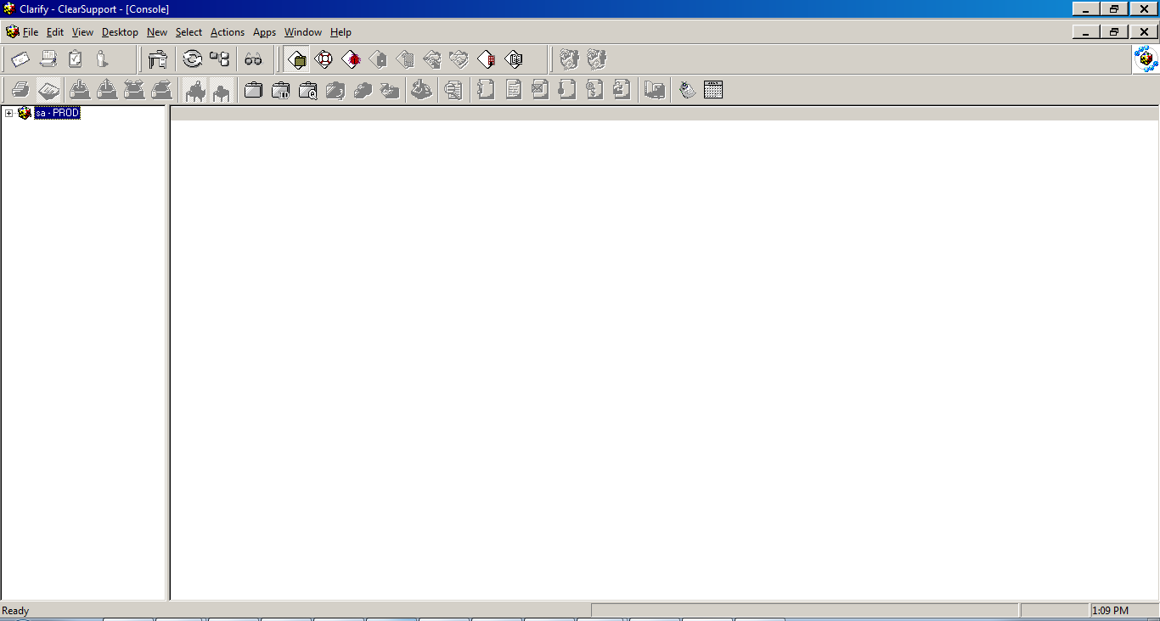

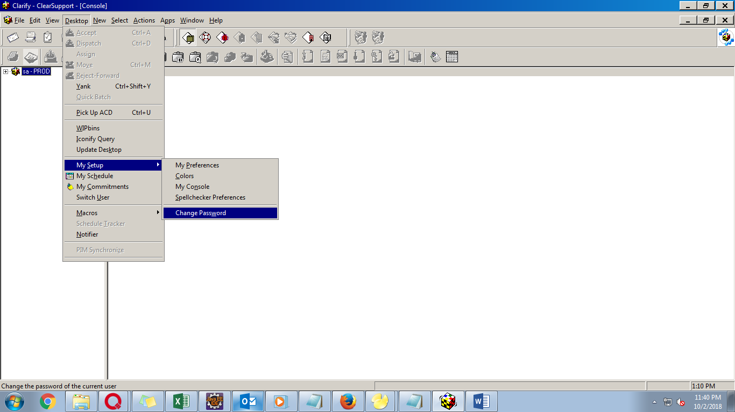

User Name- Clarify Login name,

psc_m_xyz

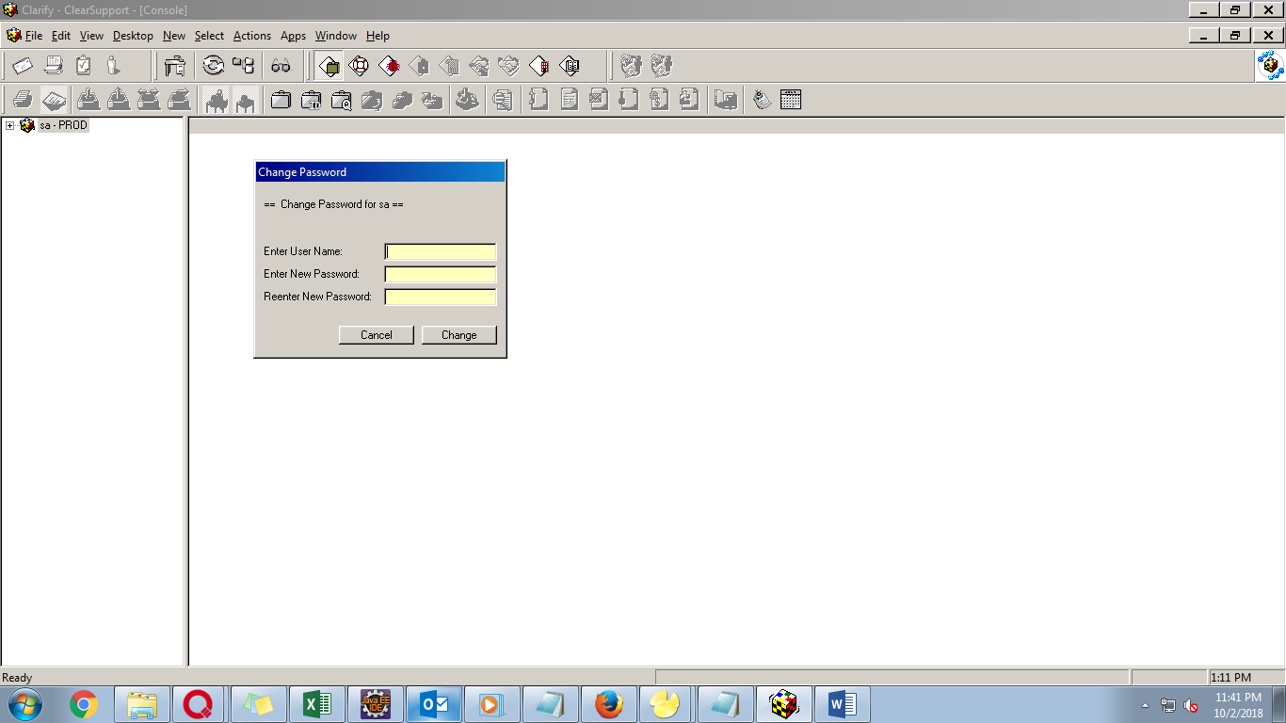

1. Creating user:-

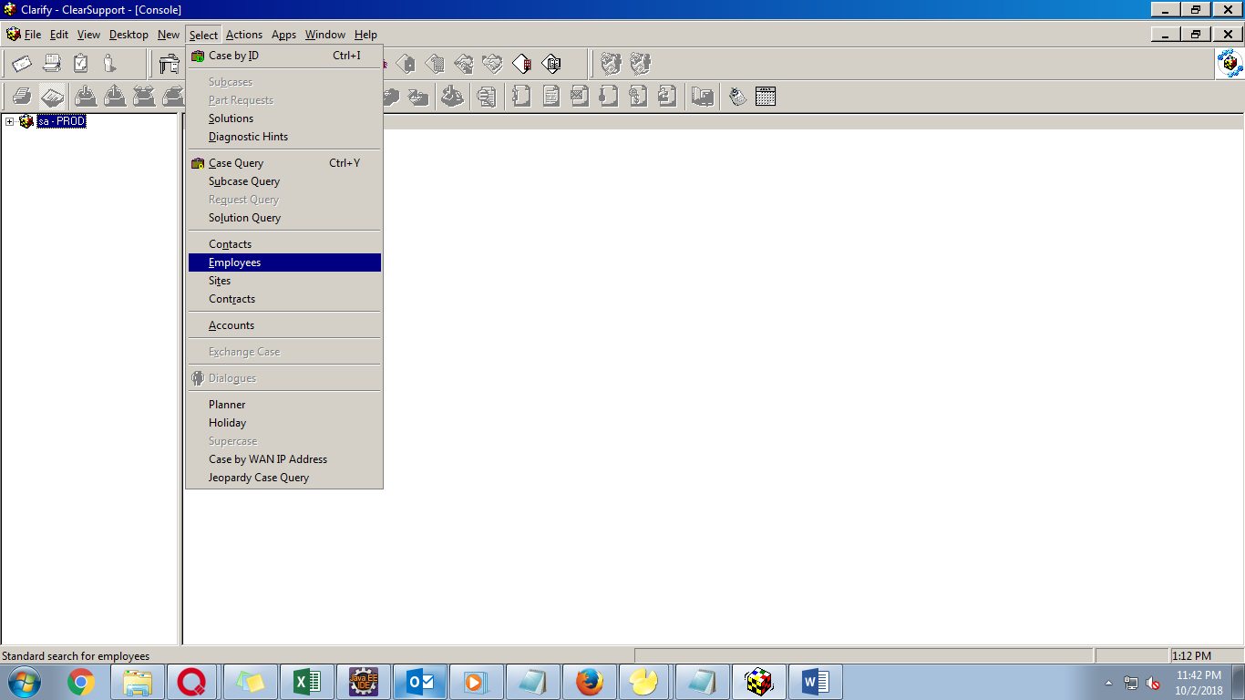

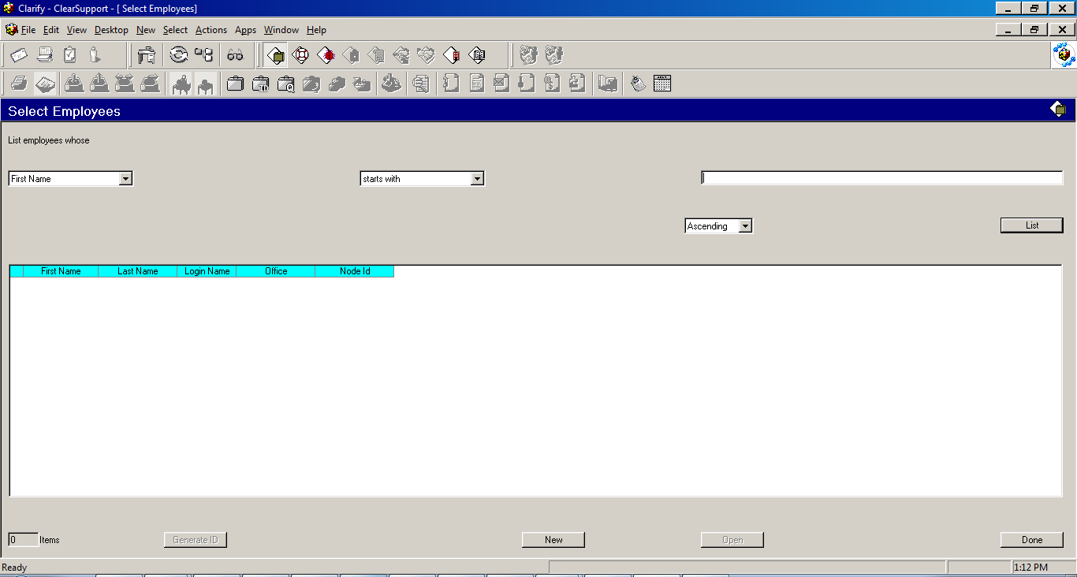

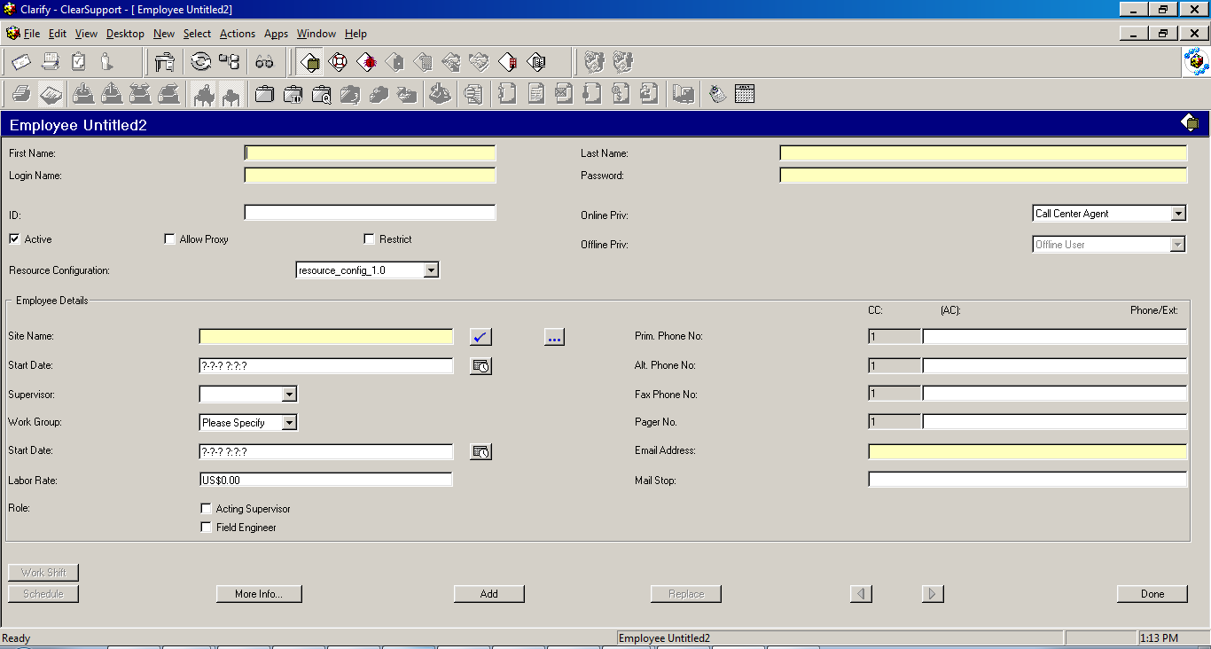

Mandatory :- first name, last name, login name, password, online priv. resource config, site name, email address

1. Finding User:-

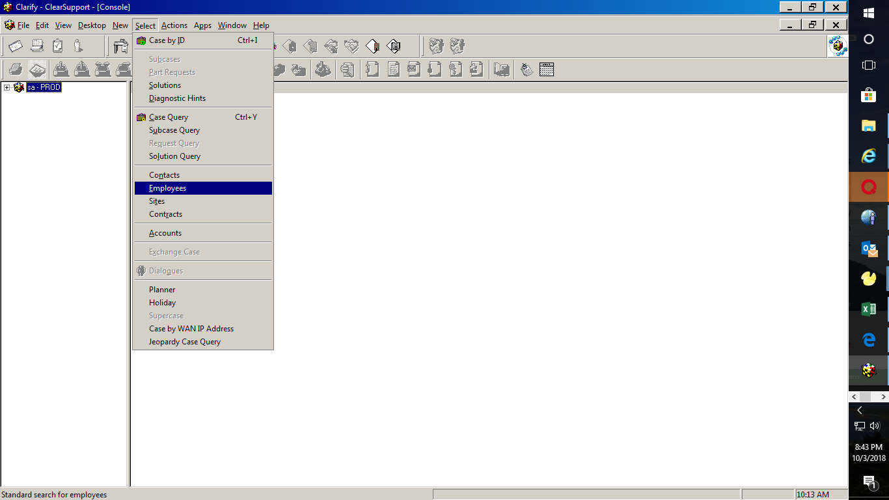

Based on drop down list user can be found using name, last name, login_id, office site etc

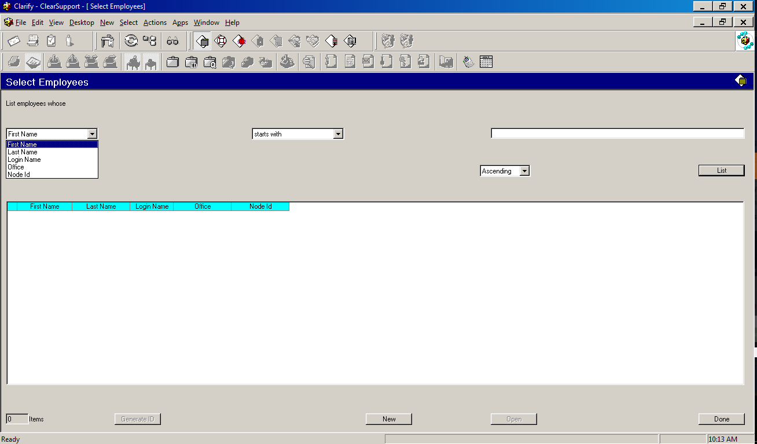

1. To check Sites :-

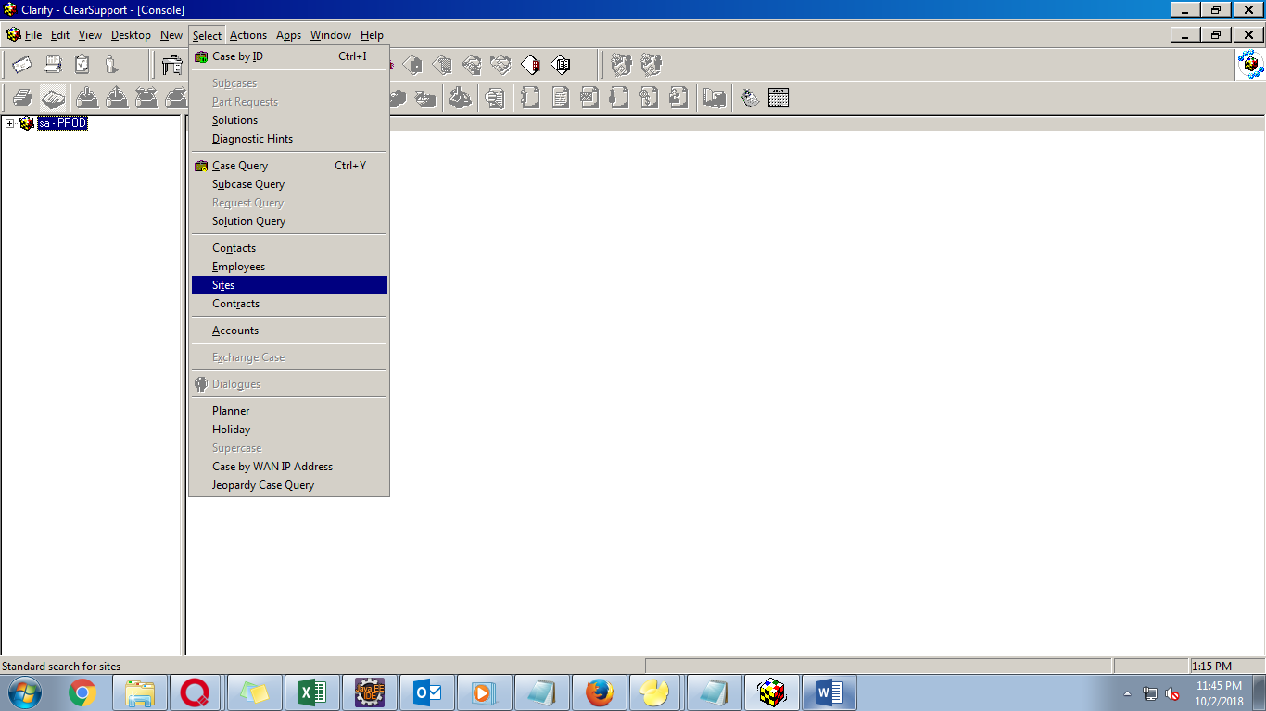

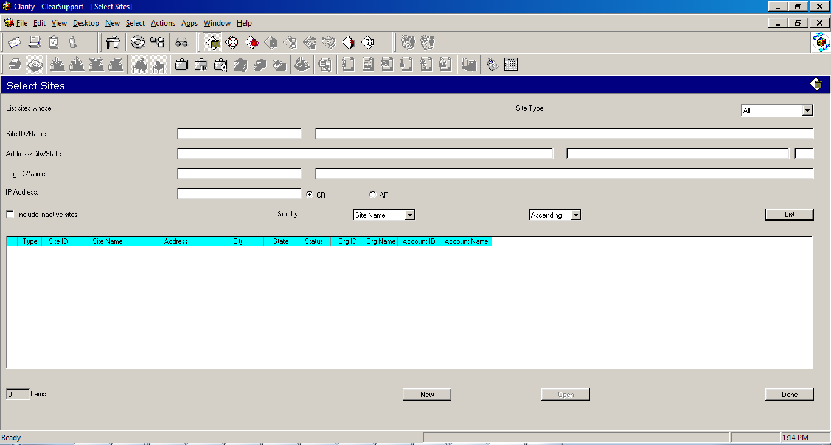

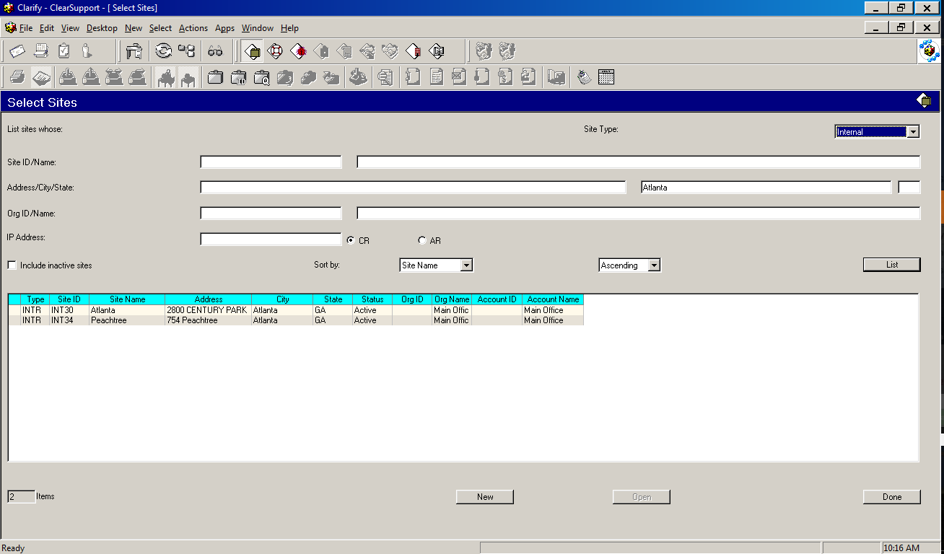

To create a New site click on New tab, Populate INTR as Customer ID/Name followed by populated of required fields and click ADD

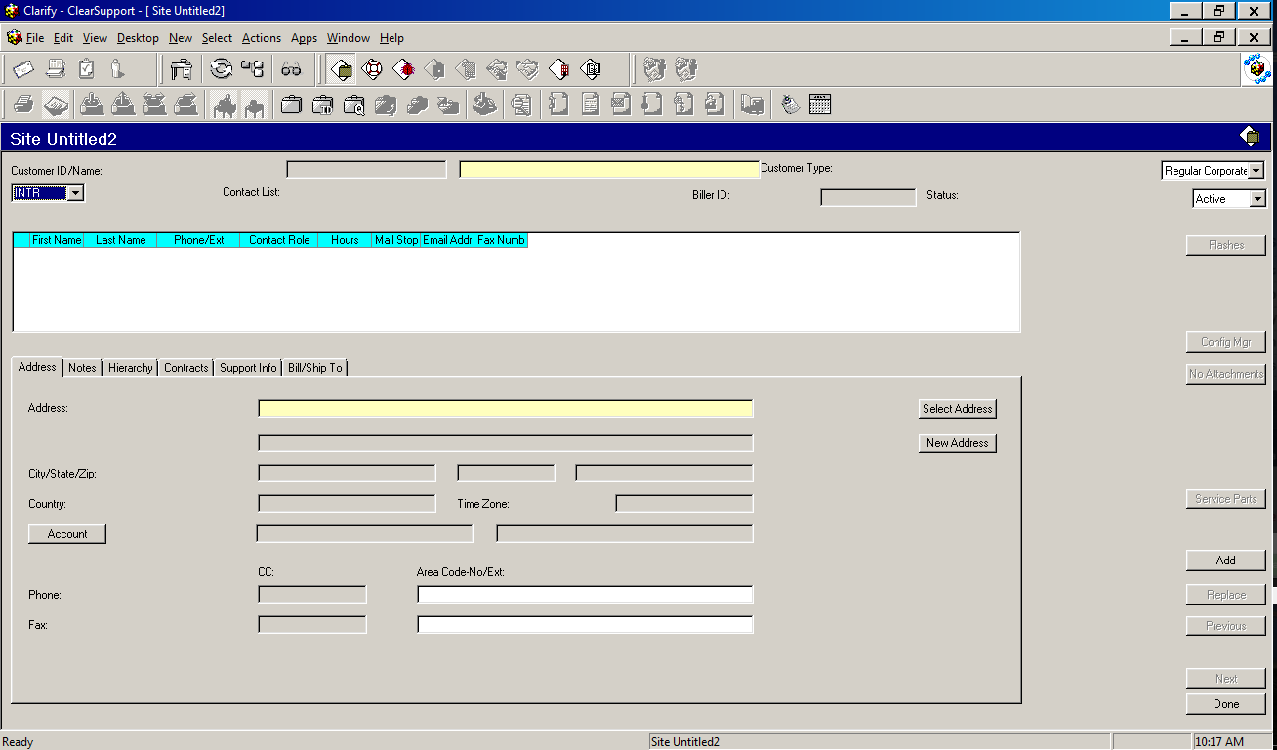

1. To Open a MIS Clarify Case:- ctrl + i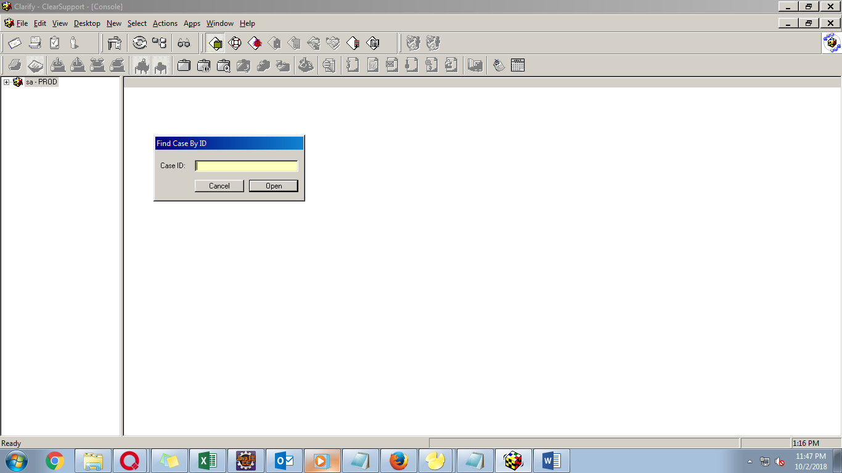
2. MIS Case screens:-

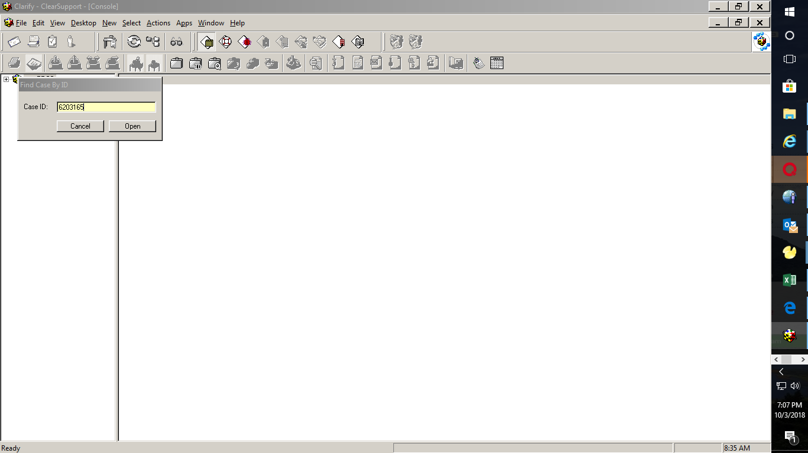

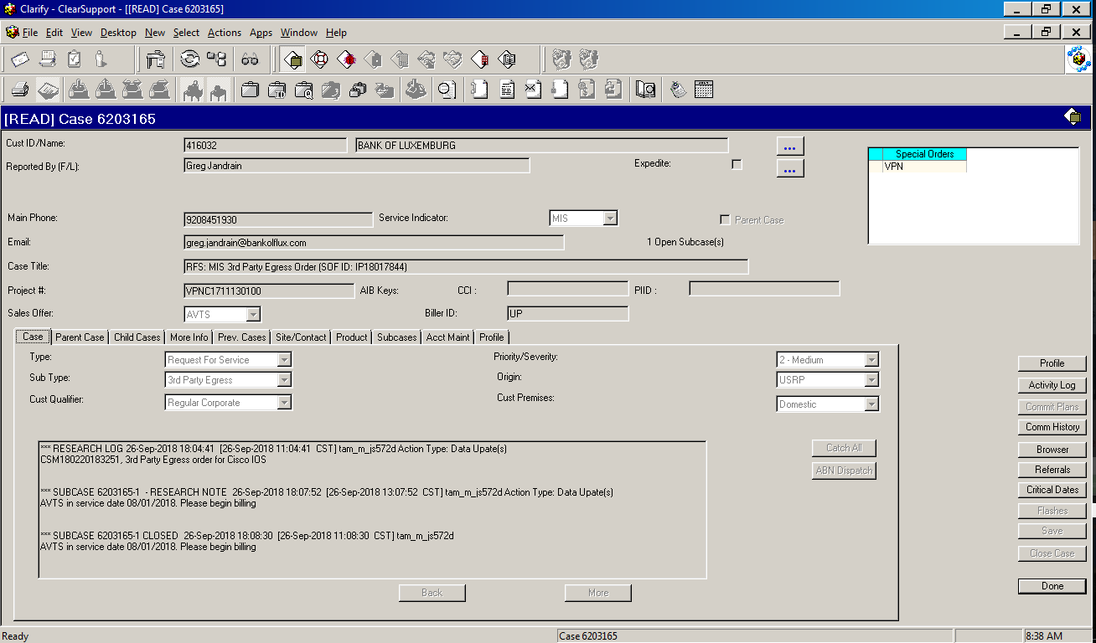

MIS cases have subcases (billing, testing etc)

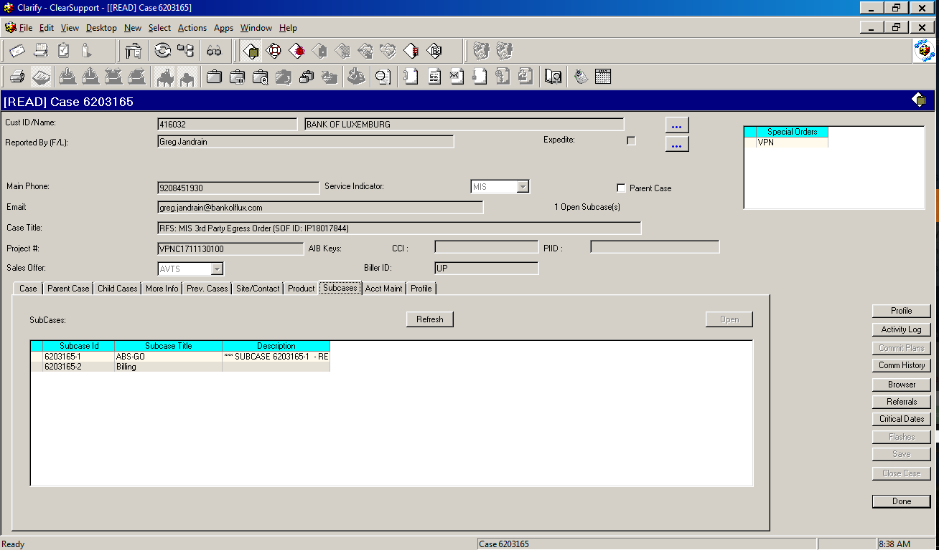

Billing subcase is accessed in order to push a MIS order to billing

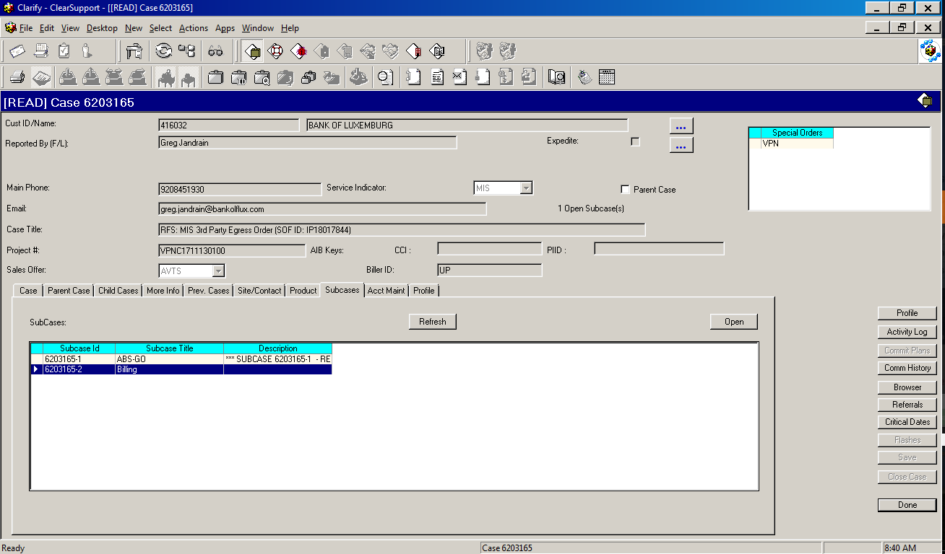

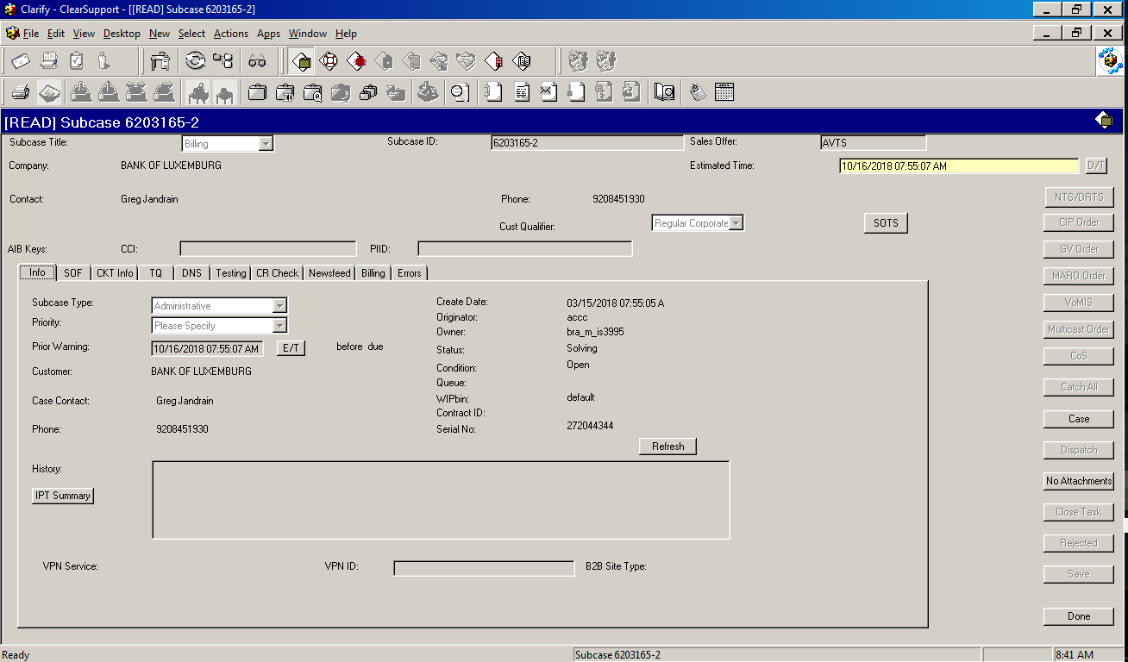

Highlighted fields are used to push order to billing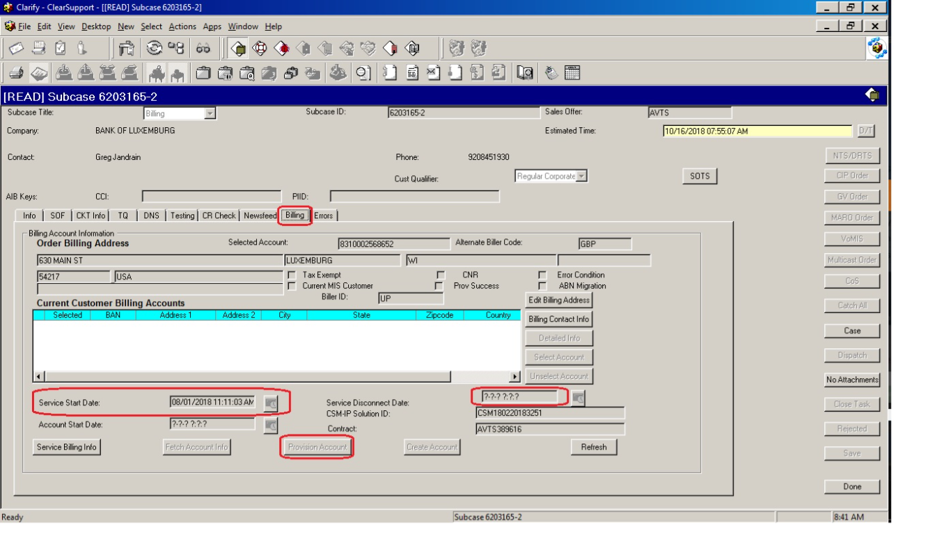

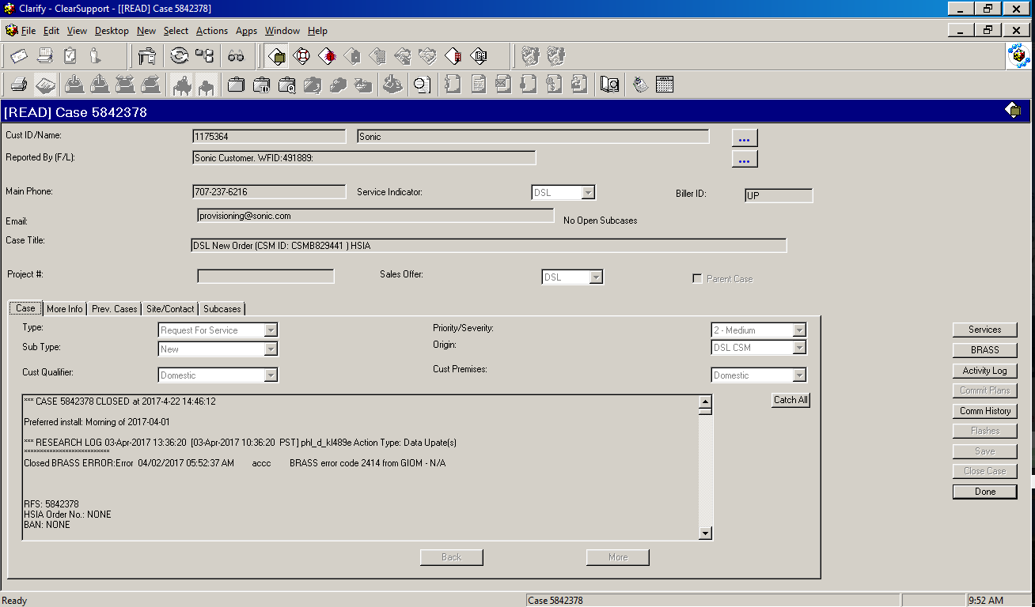

Activity Logs are used to check general info

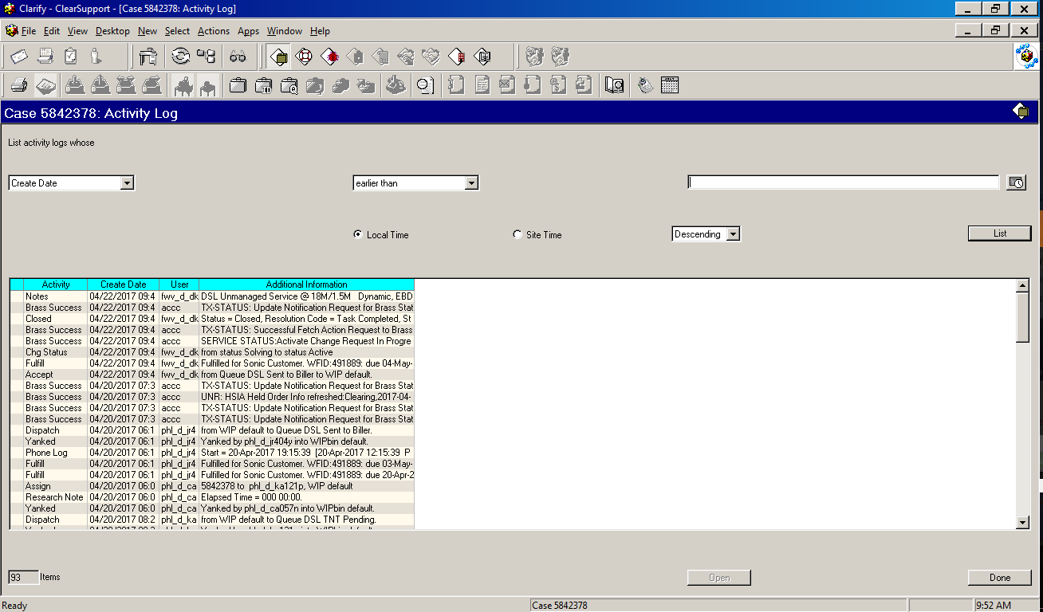

Disconnect tab used to disconnect order manually to billing/Brass

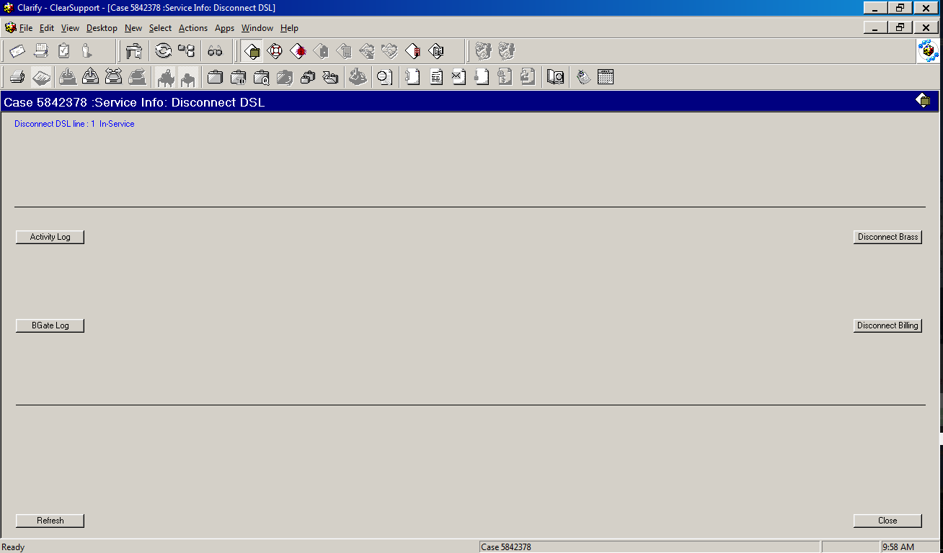

View CPE tab used to access CPE & Router info

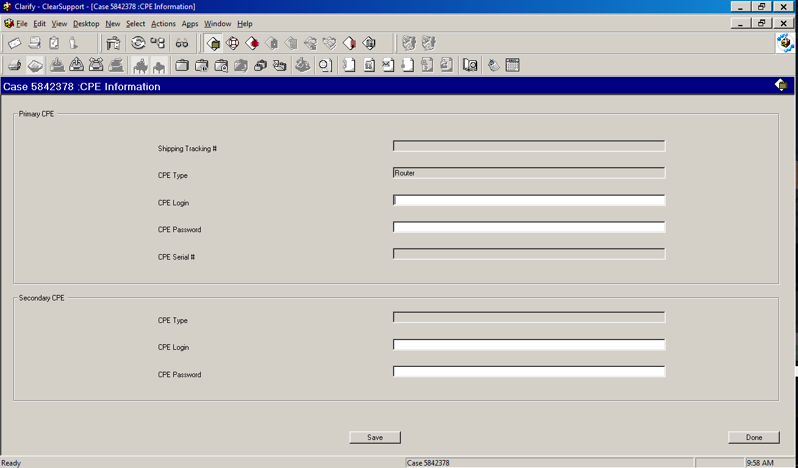

HSIA tab accessed to see HSIA related info

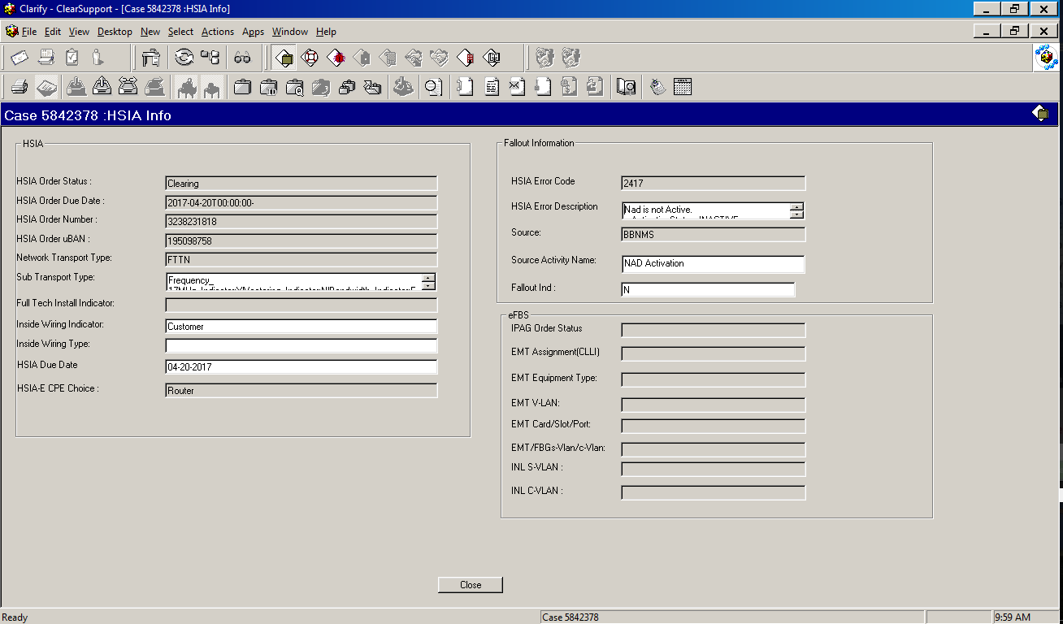

Clicking Modify Service sends request to BRASS with the updated information, which would require retrigger to be done in order to push order to billing.

To close an open case the Close case tab is used from the main screen

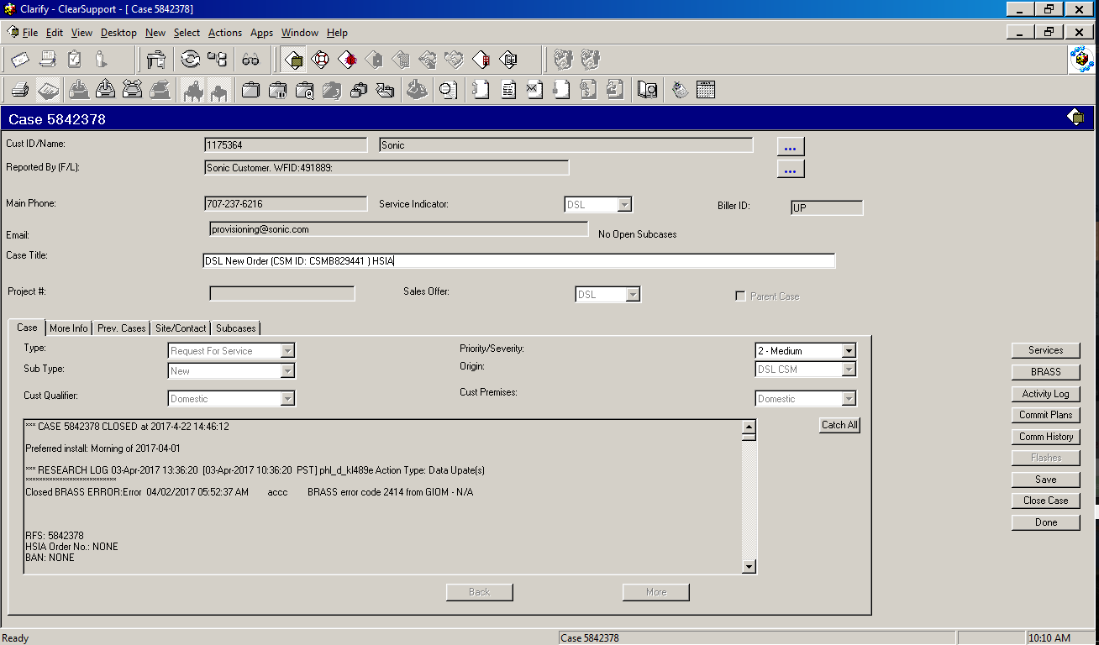

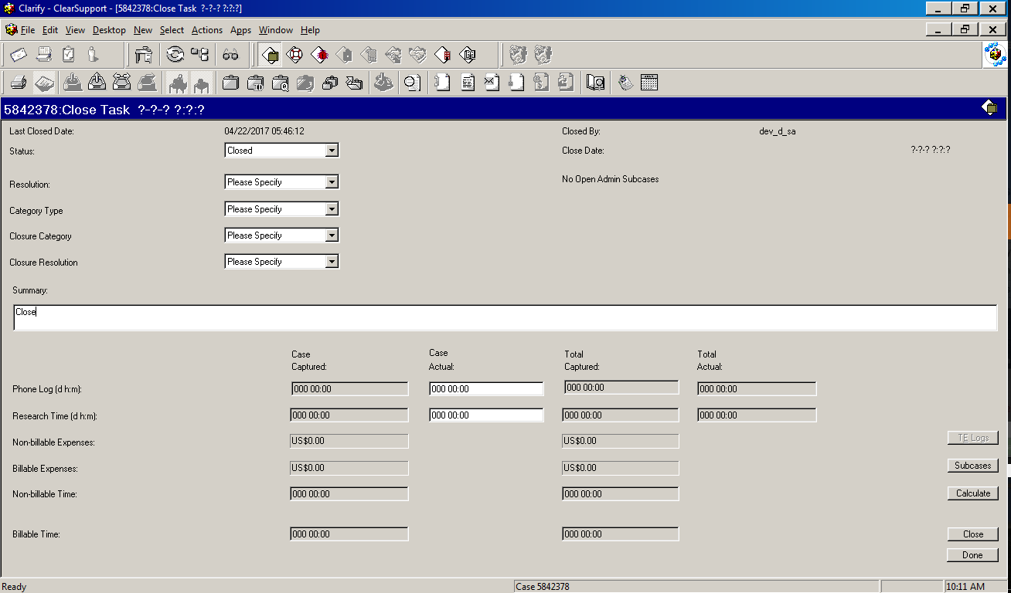

1. To revert to SA mode :-

Desktop>switch user>click on revert

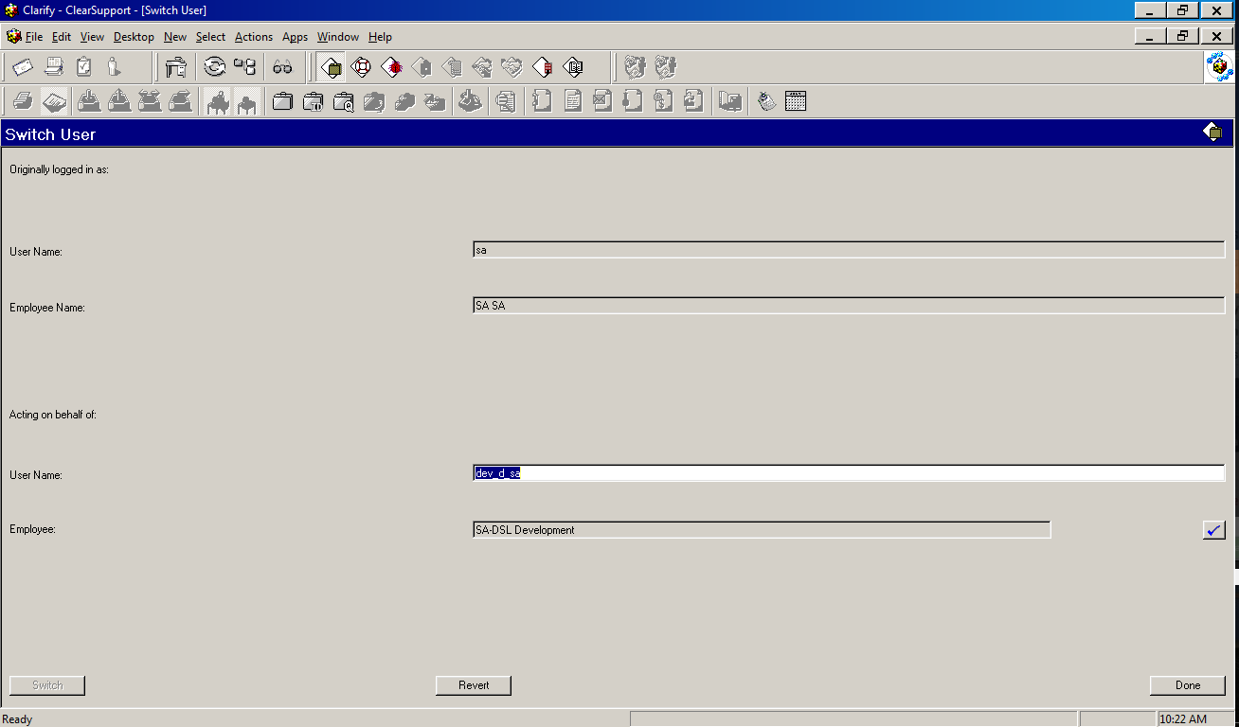

1. To re-enable Clarify GUI ( GUI gets disabled after 80 minutes of inactivity):-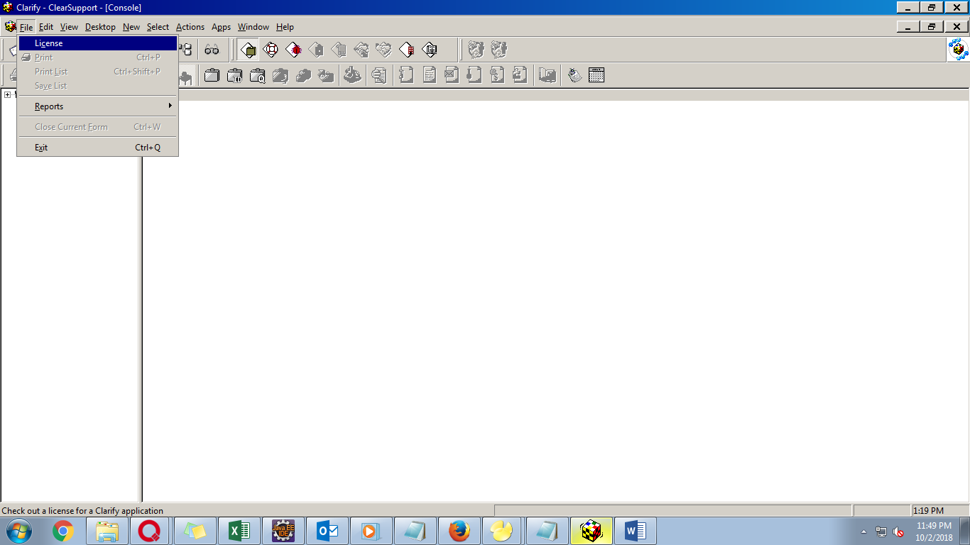

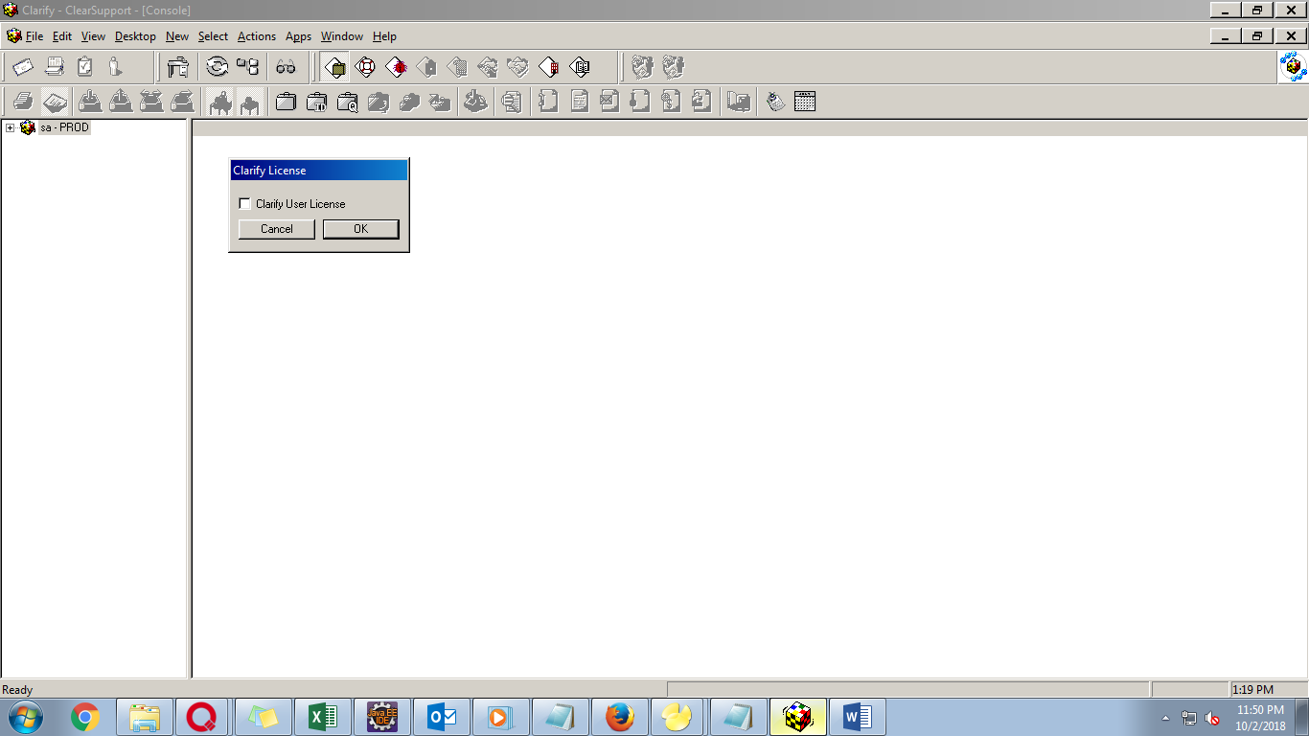

1. To select and reassign user to desired Work Queues :-

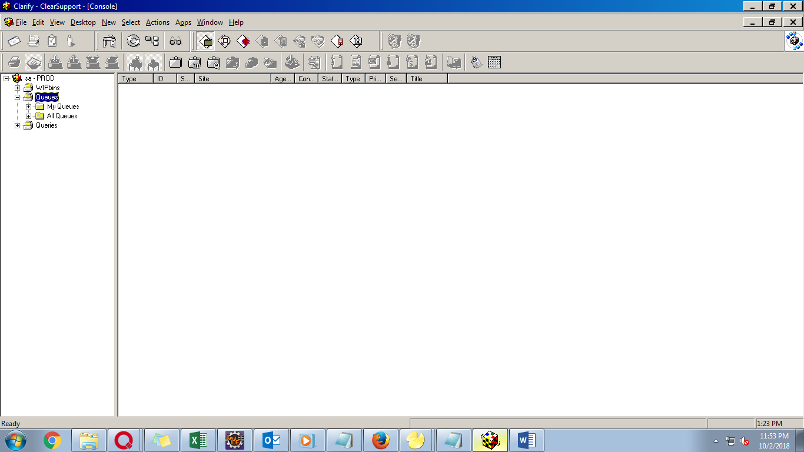

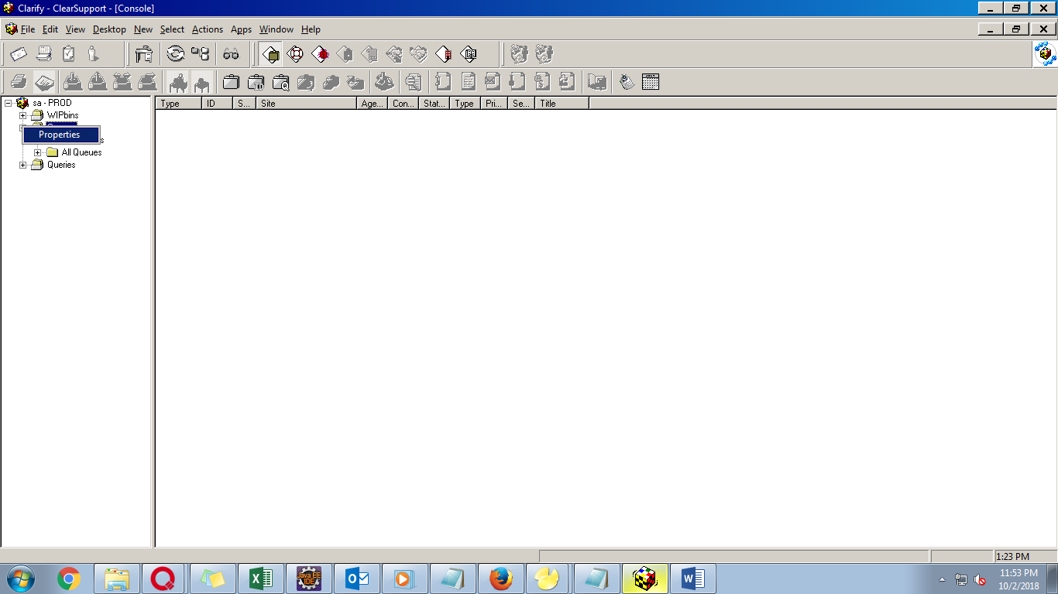

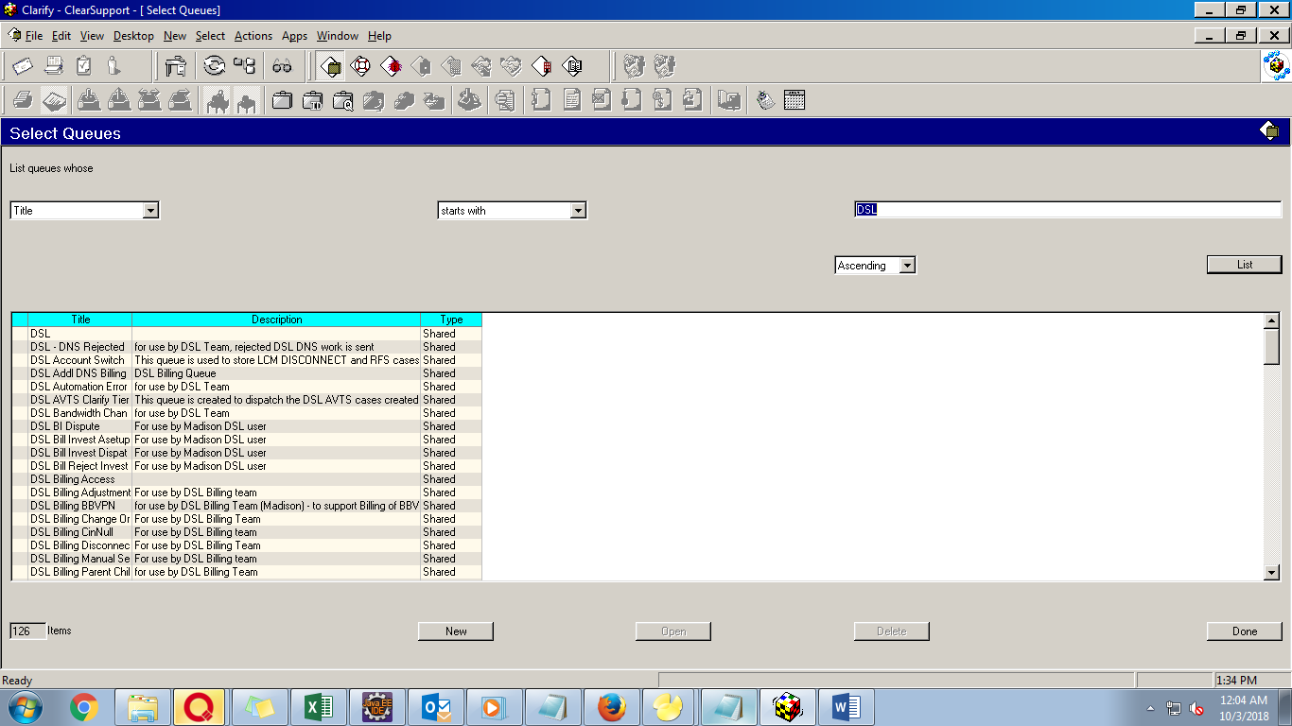

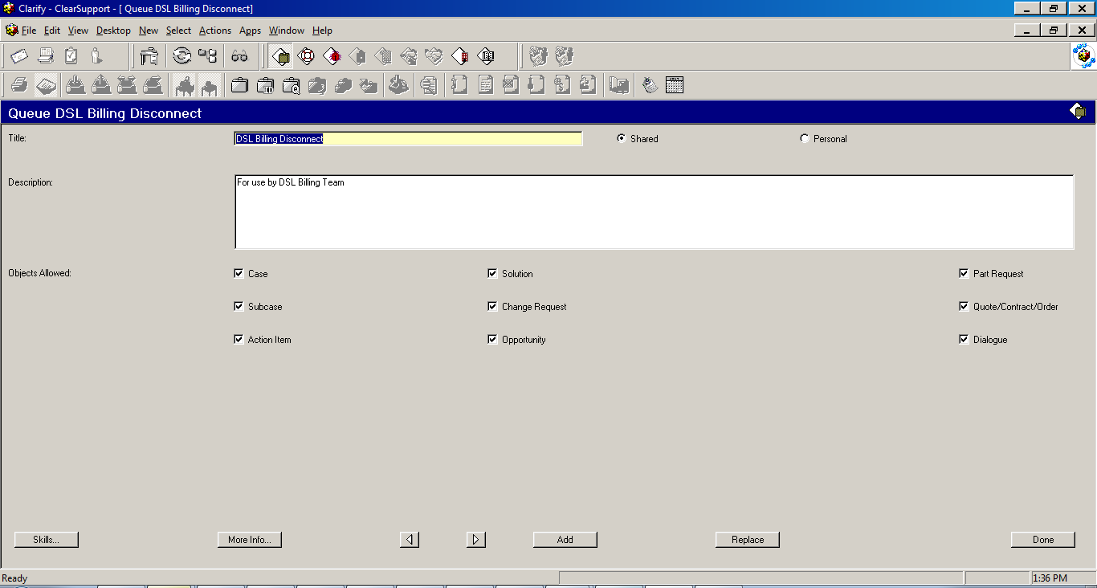

Click More Info button to access following screen

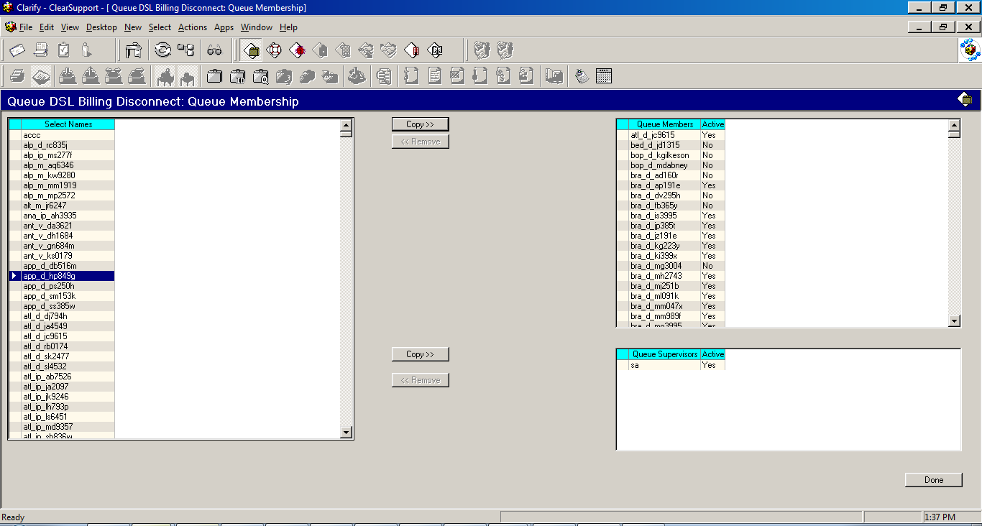

After reassigning user from left column to right click done, then Replace on the previous screen.